**Aim:** To demonstrate the transmission of a simple PDU between 2 devices connected using a hub and a switch.

1. **HUB:**

**Topology:**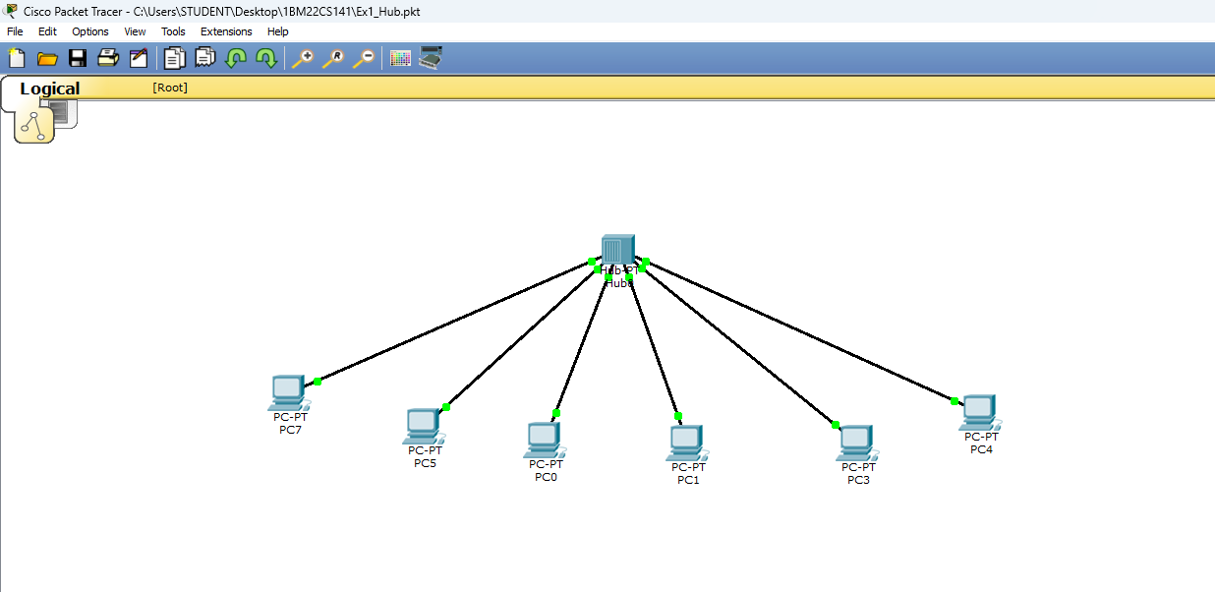

**Simulation:**

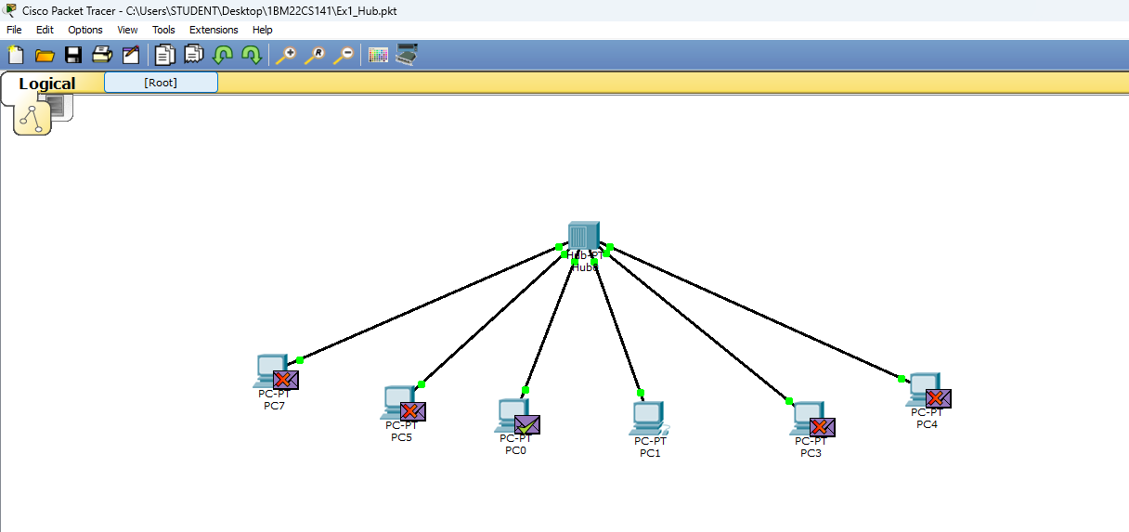

**Lab Observation:**

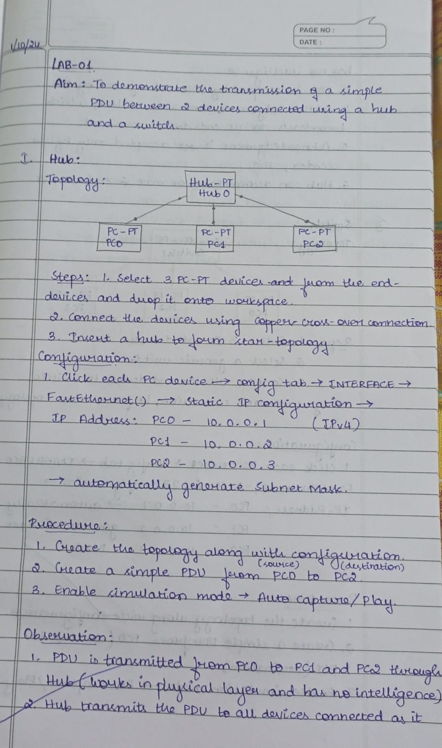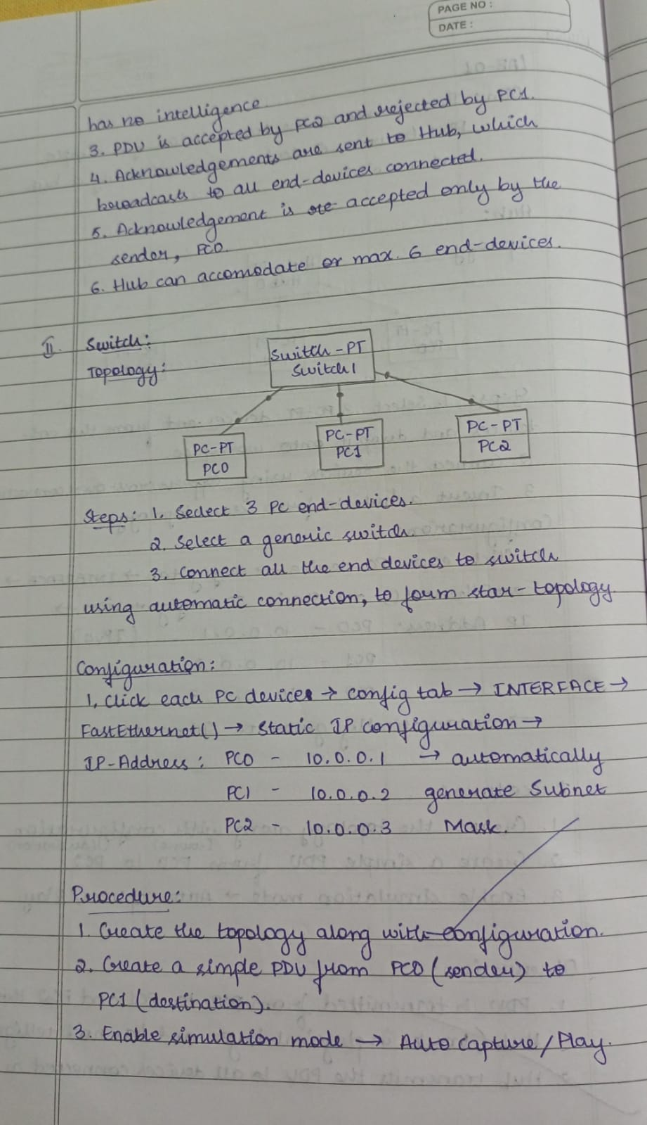

1. **SWITCH:**

**Topology:**

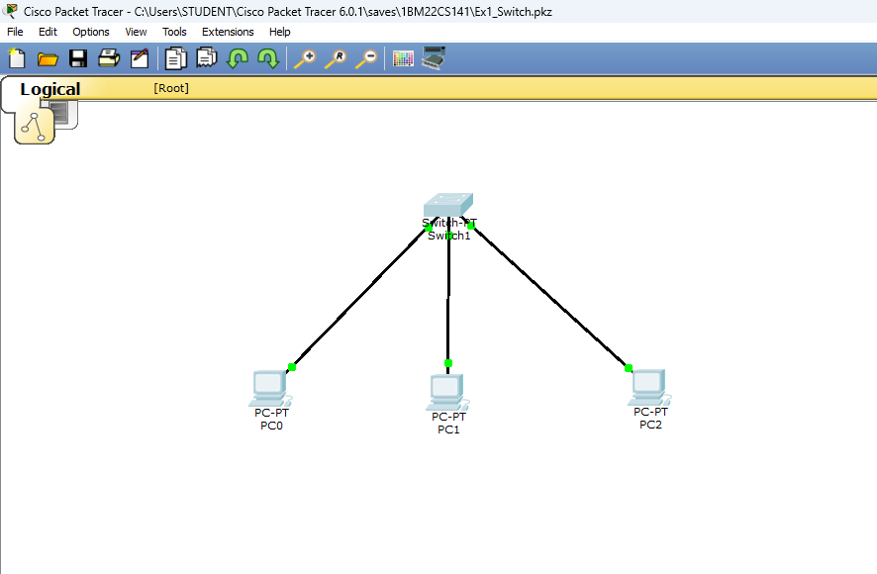

**Simulation:**

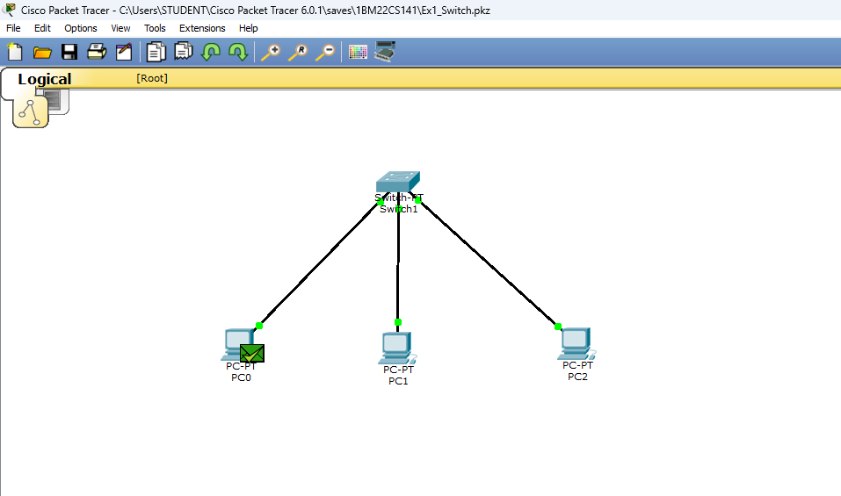

**Lab Observation:**

